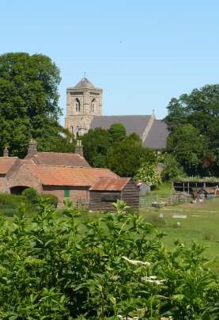

The Newsletter for Middleton on the Wolds

Issue No 26

JUNE

2021

NEXT COPY DATE
14th June

Please send in your contributions to middletonflyer@yahoo.com by the end of the copy day.
If I don’t acknowledge them please get in touch to make sure they have arrived.
In the absence of a stack of photos flooding in for the front page I have again raided my archives. This one was taken in June 2010. I suspect you are all saving your best shots for the Virtual Produce Show or the Gala Day.
Lyn
4 The Paddocks 219500

ADVERTISING COSTS for the Messenger
Rates Month Year

Whole Page £25 £150

1/2 Page £15 £100

1/3 Page £10 £60
Full colour - Print run 500 copies
Contact: Tina 01377 217242, middletonflyer@yahoo.com

editorial
I’m starting, this month, with the recent election for Police and Crime Commissioner for Humberside. Did anyone in Middleton actually receive any information about any of the candidates? All the political parties are continually urging us to use our vote but if they are not given information with which to make an informed choice, why should they be expected to bother. My
view is that if you haven’t voted, even by just spoiling your ballot, then you have no right to complain – but they don’t make it easy, do they?
More enjoyably, summer’s here and the time is right for getting out into the countryside and enjoying nature. There are several trails and paths around the village, and they are not just for dog walkers. With all the beauty of the Wolds around us it would be daft not to take advantage of what is on our doorstep. It is close, it’s in your control and it’s free! If you do go out, please follow the Country Code; do not drop litter, stay to the paths, and try not to walk on crops unnecessarily. This applies anywhere but especially so when you are not using official public footpaths. Use of any other trail, say beside a field or through a wood, is with the good will of the landowner; let us not abuse their generosity.
You will notice that this edition of the Messenger contains no reference to poo (apart from this one, of course). It’s not that the problem has gone away, it’s just that you’ve heard it all before and we don’t want to be thought of as a single-issue magazine.
Stay safe.
Mike
If you have any ideas, comments or complaints (especially complaints) you want to share then send an email to middletonflyer@yahoo.com. Remember, we can’t respond unless we receive your message.

correspondence
Dog ownership is as popular as ever, which is demonstrated by the ever-increasing price of puppies. The Labrador retriever is the nation’s favourite breed, but I was interested to see how many pure breeds of dog there are in the village; here are the results of my survey divided into the six Kennel Club groups:
Continued overleaf

Terriers: Airedale, Bedlington, Border, Cairn, Maltese and Staffordshire Bull.
Gundogs: Cocker Spaniel, Springer Spaniel, Golden Retriever, Labrador Retriever, Hungarian Vizsla and Weimaraner.
Hounds: Dachshund, Greyhound and Whippet.
Working: Border Collie, Belgian Shepherd Dog, German Shepherd Dog, Mastiff and Rough Collie.
Utility: Dalmatian, Miniature Schnauzer, Miniature Poodle, Shar Pei and Boxer.
Toy: Yorkshire Terrier.
In addition, there are lots of mongrels including the popular cockapoo, a cross between a cocker spaniel and a poodle.
My apologies for those I’ve missed!
Sheelah Bamford, Greenfield Road
Thanks for this, Sheelah; I’m sure owners are already trying to get their pet’s breed added to the list!

Mike

The wolds METHODIST CHURCH bainton
Services for June
Sunday 6th 10.30am | Service at the Wolds Methodist Church,
 | Mr Keith Russell
Sunday 13th 10.30am | United Service at St Andrews Church Middleton
Sunday 20th 10.30am | Service at the Wolds Methodist Church,
 | Mr John Stephenson
Sunday 27th 10.30am | United Service at the St Pauls Methodist Church,
 | Wetwang, Mr Stephen Byass

QUIZ PAGE
If you are caught committing a crime you would said to be
- caught....?
The Crown is the logo of what luxury watch company founded
- in 1905?
Purple one and orange crunch feature in what chocolate selection
- box?
- Which is the oldest Scottish University?
- Which king led England into the 100 years War?
- What is the highest number used in a standard bingo game?
- Laurel and Hardy wore what type of hat?
- What flowers are named in the first line of My Favourite Things?
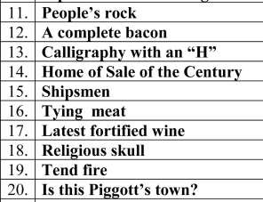
- What is the capital of Lithuania?
Quiz set by Rowland Wooldridge

All answers on
page 21

CRYPTIC

TOWNS & CITIES

NAME THE
BRAND

- Which planet begins with two vowels?
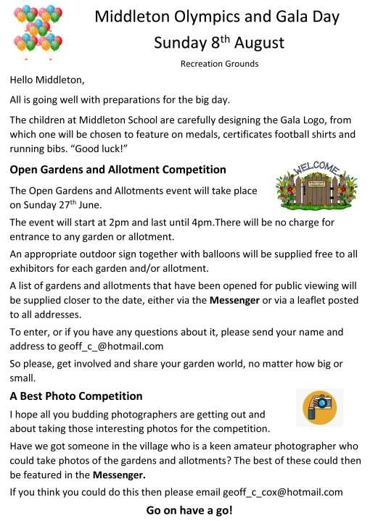

LOCAL HISTORY

BETWEEN TWO WORLDS
Next year will mark the 70th anniversary of the death of King George V1 and the accession to the throne of Queen Elizabeth, so it is interesting to think about the state of the country at that time and how it affected the people of Middleton and the locality
With the war over, people had begun to wonder why rationing had become even more severe than during the conflict. By the late 1940s for instance
the bulk of items needed for personal consumption or rebuilding the war damaged country were either in short supply or unobtainable, hence the general feeling of dissatisfaction. Envious glances were made towards America which seemed to be a land of plenty while the British joined the ration queue or waited for a food parcel but the supply of some basic foodstuffs were more readily available in rural than urban areas.
Sweets were taken off ration in 1949 but people (particularly children) descended on the shops like a plague of locusts and emptied the shelves thereby necessitating the reintroduction of coupons until just before the coronation. In Middleton Tom Soanes recorded in his diary on the 27 March 1953 “Eggs off ration”, though these had probably been readily available in most villages. On 24 April 1953 the Driffield Times directed people in Middleton to the school to obtain their new ration books. The government had a positive attitude regarding agriculture and full employment and during this period Clement Attlee the former prime minister who was ousted in 1951 emphasized this fact to his audience when he visited Driffield.
Socially the country experienced a brief return to pre-war values; capital punishment was still in force; unmarried mothers and divorce were frowned upon and male homosexuals were pursued by the law with greater vigour than in the 1930s. Sunday was a day of rest when most shops were closed. Half day closing on one weekday afternoon and the small number of motor vehicles could make market towns seem deserted. Tentative attempts at self service grocery were hindered by shortage of supplies. Cafes and other eating establishments could seem pretty basic but fish and chips remained a popular item..
On the positive side the country with the aid of strict licensing laws was experiencing a lull in alcohol consumption between the highs at the beginning and end of the century but cigarette smoking was widespread amongst all classes but the first ominous warnings of the cancer threat were being made. Betting was a much more furtive pastime than at present and foreign travel remained a minority activity.
The country at large was entertained by the cinema, some of the most memorable films being the Ealing Comedies one of which, “The Lavender Hill Mob”, was being shown in Bridlington during the week of the King’s death. The radio, a BBC monopoly, was still the main source of broadcast entertainment with its classic half hour comedy programmes subject to rigorous BBC censorship, but one
offering “The Goons” could at times fool the censors with its anarchic jokes and strange characters (much loved by schoolboys). The Home Service and the Third Programme catered for middle and highbrow tastes. For those who tired of the BBC’s efforts the answer was Radio Luxemburg which broadcast nightly from abroad with a diet of pop music and banter.
One Sunday programme which became as indispensable to many people as Sunday lunch or a popular newspaper was heralded with the announcement “The time in Britain is twelve noon, in Germany it’s one o’clock but home and away it’s time for Two Way Family Favourites” which enabled families in Britain to keep in touch with relatives serving in postwar Germany often by compulsory national service. The popular music of the time before the emergence of rock and roll some 3 years later still largely consisted of dance bands or orchestras with male or female vocalists singing songs with lyrics of an unthreatening nature with little of the “edginess” of later years.
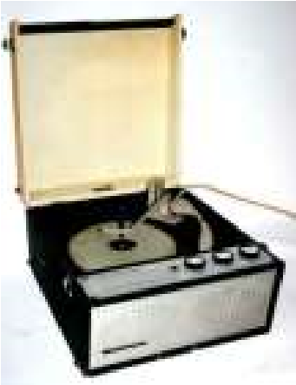
The “hit parade” based on the sale of records started on the 14th November 1952 with Al Martino’s rendering of “Here in my heart” coming top. Before that the assessment of number 1 was based on the sale of sheet music without reference to a particular artiste and in February 1952 the winner was “Loveliest night of the year” with recorded versions by Mario Lanza and Anne Shelton This was the age of the long playing vinyl record and its smaller cousin the 45 often reproduced on a Dansette record player.
About this time an advertisement appeared in the Driffield Times for a
Ferguson 12 inch television with tinted tube on sale at Curry’s Driffield for 65 guineas. The BBC had a monopoly of service provision but the debate was soon underway about the proposal to allow commercial television and the then Archbishop of York entered the fray on the side of retention of the BBC monopoly but in September 1955 the British public saw their first tv advert which famously promoted the virtues of Gibbs SR toothpaste and a new age of communication had begun.
Postscript
On the 7th March 1953 the Driffield Times contained a report that the proposed Bainton and Middleton by-passes would not be carried out for the next 20 years for financial reasons: we are still waiting.
Geoff Wisher

A note from your vicar

A HISTORIC MOMENT
The Church has been closely involved in witnessing and solemnising marriages since the 11th century, and from the Reformation parishes were required to keep written record of all those married in their churches.
The Marriage Act 1836 introduced the
duplicate green register books which you may remember from your own wedding day, and whose use came to an end on the 4th May this year, on that day we officially Closed all of our Marriage Registers and they have now been deposited with the Registrar in Beverley. (though we do have the duplicate copies in church if couples wish to see them.)
For centuries it has been our privilege as a church, entrusted to us by the state, to keep these legal records of marriages.
They have recorded the acts of loving commitment made by successive couples, witnessed by their friends and family and recorded on their behalf by our clergy.
In years to come the legal record of all marriages will be held nationally by the Registrar-General, but we shall still welcome couples to marry in the church, and pray that God will bless and support them in their lives together.
Under the new system it is now possible to record the name of the couple’s mothers as well as their fathers – after a campaign led by the Bishop of St Albans who sought to address this long overdue omission. Also, the couple can now include step and adoptive parents on the Marriage Document which will be signed at the end of the service in church. This Document will be sent to the Registry Office within 21 days of the wedding taking place and the couple will apply for their Marriage Certificate from the Registrar.
As a Benefice we will be presenting a Marriage Keepsake to the couple at the end of their service in church – this is not a legal document, but a beautiful memento of their special day. It has been designed for us by Will Adamson from Kilnwick.
Over the past year many couples have sadly been forced to postpone their weddings but slowly and cautiously they are now rearranging their services. We do look forward to welcoming them and their families and friends into St Andrew’s, Middleton once more as we celebrate the love and commitment which has brought them to seek God’s blessing on their very special day.
Jane

St Andrew’S church

Sunday 6th.June. Morning Prayers at 10.30.a.m. C/W.

Sunday 13th.June .Joint worship at 10.30.a.m. Rev`d Jane Anderson.

Sunday 20th. June. Holy Communion at 10.30.a.m. Rev`d Canon Kate Goulder.

Sunday 27th. June. Holy Communion at 10.30.a.m. Rev`d Ruth Newton.

Recipe – Maids of Honour

Makes 12

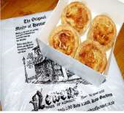
Preheat oven 200c / 180c fan Gas 6

Ingredients:
1 x 320 g Puff Pastry
200 g Curd Cheese (cottage cheese)
30 g Candied Peal (finely chopped)
30 g Caster Sugar
Zest of 1 lemon
25 g Ground Almonds
1 Medium Egg plus 1 Egg Yolk
30 g Raisins
2 Tablespoons Lemon Curd

- Using a 3-inch cutter cut out 12 discs from the Puff Pastry and line your lightly greased bun tin.
- In a bowl combine Curd Cheese, Candied Peal, Caster Sugar, Lemon Zest & Ground Almonds.
- Beat together the Egg and Egg Yolk and add this to the Curd Cheese mix.
- Divide the Lemon Curd into the 12 pastry cases.
- Top with a heaped teaspoon of Curd Cheese mixture.
- Sprinkle raisins on top of the tarts.
- Bake for 20 minutes until mixture is puffed and golden.
- Remove from oven, place on wire rack

These can be eaten warm or cold. Don’t over fill the cases or they will spill out as they bake and you will have horrid burned bits welded to your baking tin.
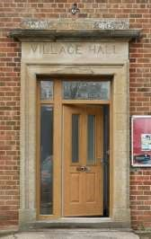
Sunday 27th June

2.00
to 4.00pm

Enjoy a glass of Bucks Fizz

while you take a look at
the newly refurbished
Village Hall.

Village hall news
REFURBISHMENTS I am sure you will have noticed our smart new front door. That is just one of the refurbishments and improvements that have been taking place in recent weeks, due in part to grants from The HEY Smile Foundation, the Landfill Communities Fund from FCC
Communities Foundation, the Lottery Community Fund and the legacy from Regina Bradley.
The acoustics have been dramatically improved by lowering the ceiling and the building will be more energy efficient now with cavity wall insulation, led lights and a new boiler. BUT THAT’S NOT ALL!
OPEN DAY On Sunday 27th June we will be opening the Village Hall from 2.00 to 4.00pm for everyone to come and see for themselves how it has changed. So, while you are walking round the village looking at the Open Gardens, please pop in to join us for a glass of Bucks Fizz (or non-alcoholic alternative) and have a look around.
REGULAR CLASSES The regular classes will be recommencing
(government permitting) on week commencing 21st June. If you, or anyone you know, would like to start up a regular class please get in touch.
PRIVATE HIRE The Hall will be available for hire from 21st June and you can contact me to book on 219500 or lyndennis456@gmail.com.
Lyn & the Village Hall Committee
GENTLE YOGA CLASS
Are you interested in joining a new gentle yoga class?
We have had enquiries from a qualified Yoga teacher who would like to start a class here. Please let me know when would be a suitable time for you – weekdays, evenings or weekends.
219500 or lyndennis456@gmail.com.
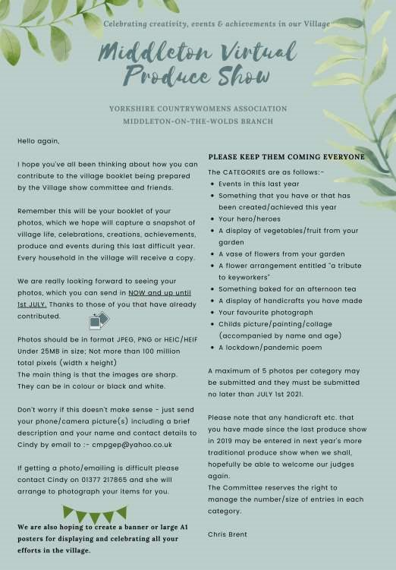

Middleton on the wolds ce ve school
Executive Headteacher: Mrs E Harros
Station Road, Middleton on the Wolds, Driffield YO25 9UQ
E-mail:middleton.primary@eastriding.gov.uk Tel: 01377 217323

Middleton Minis
Our parent, carer, baby and toddler group runs from 1:30 to 3:30pm every Tuesday afternoon (term time only) at Middleton on the Wolds primary school. Drop in for 20 minutes or the full 2 hours. We look forward to seeing you.

On-going Collections
On-going Collections – We collect used stamps and used batteries. Please note we are not currently collecting used printer cartridges or mobile phones until we can source a new company to collect and recycle them. Thank you

Middleton on the Wolds Nursery
At Middleton on the Wolds CE (VC) Primary School

 Providing education for 2, 3 and 4 year olds Monday - Friday.
 We accept the Government’s childcare vouchers for up to 30 hours of free provision for 3 year olds (conditions apply)
 Additional sessions can be purchased for £13.50 per session for 3 year olds and £15.75 for 2 year olds.
 Lunchtime sessions are £1.75 (free if children attend for the whole day) with the option to purchase a school meal for £2.40.
 Children are welcome in the term after their 3rd birthday for funded places.

For further details, please contact: Sharon Stone
Email: middleton.primary@eastriding.gov.uk Tel: 01377 217323

We break up for Half Term Holidays on 28th May and return June 7th 2021

Parish council
Members of the PC attended a virtual presentation on plans to lay a power cable to transfer wind-generated electricity from Peterhead in Scotland to Drax power station. The project forms part of the work to help the UK achieve net zero carbon emissions by 2050.
The cable will run down the North Sea before coming ashore at Wilsthorpe, South of Bridlington and is of interest to us because it will pass near us, between Middleton and Lund. The National Grid are keen to make reparations for the inconvenience the work will cause and, as well as supporting local charities, they have a community grant programme which is open to funding applications from not-for-profit organisations along the route of the cable.
You can view more details of the proposal on the PC website at middletononthewolds.co.uk.

Cemetery Bench
You may have noticed that the bench in the cemetery has disappeared. Don’t worry, it hasn’t been stolen but has been taken by a kind resident who has offered to repair it. Thank you for your generosity of spirit.
Mike Kelly

Recreation Ground Play Equipment
The start date for the new equipment is now 21st June 2021, due to bad weather delaying a current project.
Cllr Tina Walker
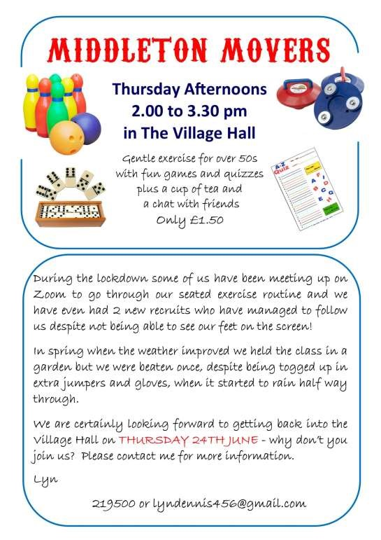

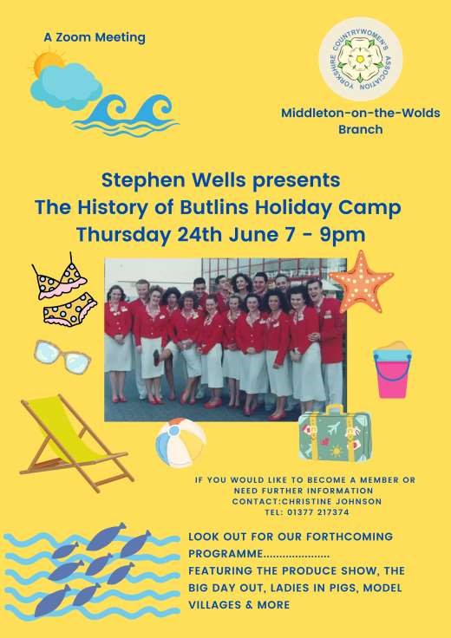

Middleton book group
The book group met again to discuss two very different books.

The Thursday Murder Club by Richard Osman
This first book by a well known person had attracted everyone’s attention. It did not disappoint. Based in a peaceful retirement village, four residents meet up to investigate unsolved murders. Then, right on their doorstep, a brutal killing and they take on their first live case.
Club members enjoyed this book, finding it smart, compassionate, warm, moving and funny and it is highly recommended to make readers happy.

The second book To Everything A Season by Lauraine Snelling is a historic novel covering the early 20th century in Blessing, North Dakota. Difficult Norwegian names did put some off reading this first in the Authors Red River Valley series.
It had many interesting characters: the two female doctors who provided all health care whilst running the hospital, the younger brother of the brothers who attempted to rob the bank and who broke a leg which led to amputation and the trainee nurse who came to Blessing on placement to finalise her training which she could not get through quick enough so she could get back to New York and then she fell in love!!!I will certainly read more in the series and would encourage others to give it a try.

Kath

Next books for discussion:
“Redhead at the Side of the Road” by Anne Tyler “The Magic Apple Tree” by Susan Hill

We have been meeting on Zoom since the summer but expect (Boris permitting) to be back in member’s gardens, village halls or even inside homes from June. We are all looking forward to getting back to the tea and cake that follows the discussion!

To find out more about the Book Group please contact Lyn on 219500 or lyndennis456@gmail.com

Local Birds & wildlife
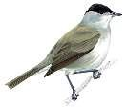
Well, it is Invasion of the Partridges in Middleton! Perhaps they have been quietly turning up in some gardens for years of course, but now more and more are appearing. I wonder if the nearest shoots are breeding more of them as a bit of a change from just pheasants, or if previous years’ birds have spread out and bred in the
_{wild?} Blakcap (male)
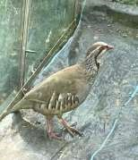
Jill had two in her garden: “One flew off and this one ran into the greenhouse” where she was able to take this lovely picture, and Pat has had further visits after last month: “I was sitting on the deck the other day listening to it’s very strange repertoire of calls. I can’t say I’ve ever heard one chatter like that. Adrian told me they are very vocal. He used to be a hobby gamekeeper and would hear them all the time when out in the fields. I’d never heard one before – always hearing pheasants though”. You can check it out
on the RSPB website, but actually there is a much better and longer clip of their calls on YouTube, posted by Marius Travell.
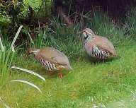
Sheelah also got in touch: “The birds are eating me out of house and home. Have a cock and two hen pheasants who spend far too much time eating here. They’ve been joined by two partridges which seem to be having full board, sleeping under the holly tree. I’m rather partial to partridge!” and Barry and Joanna have sent a great picture of a pair “taken from our dining room window. Nice to see them in our garden again after an absence of about five years.”
Away from game birds and back to more traditional garden visitors, spring has been hotting up (not literally, unfortunately).
From Pat “Looking out of the kitchen window watching all the bird activity: bluetits aplenty, I spotted a baby blackbird soon to be joined by it’s parents. We had a blackbird hit the patio door the other day, with a worm in it’s beak.
Fortunately it recovered and flew off. Seeing plenty of buzzards and kites
while out walking too. It’s all happening out there isn’t it – wonderful!”
From Barry and Joanna “Started seeing a few house martins and swallows about. Last weekend we saw our first warbler of the season, a male blackcap on the railway line opposite us. The doves nesting on our tv dish failed to hatch their first two eggs so they abandoned the nest. A few days later we removed the eggs which were infertile. They returned a short while afterwards and are sitting – we are hoping they should be hatching this weekend. We have suddenly got rooks and jackdaws on our fatballs this week, probably feeding youngsters. Have just seen first swifts of the season flying over the house – 6 in all.”
Hazel has been out and about: “Skylarks singing on the east side of the railway tracks. ‘The Lark Ascending’ was voted into the number one spot for Classic FM’s yearly count down. Composed by Vaughan Williams the violin takes the part of the skylark. Various hares (7 one day) doing what hares do. Chasing, running about and looking. I love to watch their ears when they are listening, they are like radars. Four greenfinches visiting the garden; a lovely treat. Sunday 9th May first sighting of house martins, and in the evening a racing pigeon arrived in the garden to feed, returning the next morning for breakfast!”
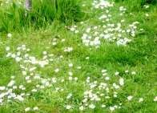
Several people mentioned more greenfinches being around this year, which is very good news. Also the odd siskin turned up again.
To finish off, did you hear of ‘No Mow May”? The idea was that lawns can be valuable for wildlife if not mowed too frequently. It was promoted by plantlife.org.uk but in fact the
impressive photo at the top of their page obviously showed lawn sown with wild flower seeds. In fact I read another article pointing out that if you simply let your lawn grow, you just end up with very long grass. Our lawns however, front and back, have been mistreated for years and so have healthy colonies of daisies and (I think) celandines, so it seems worth a go for us. We have noticed birds eating what appears to be tiny grass seeds too. I’ll be checking for increased insect activity and report back next month (and probably mow the lawn occasionally).
I look forward to hearing more from around the village – you can email me on lavenderbarbara97@gmail.com, or text 0777 192 7868
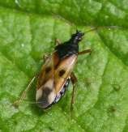
What’s Eating You?
It’s that time of the year when we all try and get out as much as possible, and then get reminded that nature isn’t all birdsong and squirrels – there are many smaller creatures out there as well!
So who is likely to get us diving for our first-aid kits or traditional remedies?
BEES. Bumblebees are good-tempered, and will only sting if they feel threatened. And before they do
they will considerately show you their stinger as a ^{Flower bug} warning. The downside is that they do not have a barbed sting, so can sting repeatedly. Honey bees however do have barbed stings, so only sting once and then die. Unfortunately however they release pheromones that can call in backups! Solitary bees (the ones that make holes in your walls or dig in your lawn) almost never sting humans. Incidentally, no male bees of any species sting, and bees are not attracted by food and drink. If a sting is still in place, scrape it off with a credit card – tweezers can squeeze more venom into the wound.
WASPS. As we all know, wasps are the bane of al fresco dining, or even just a drink in the garden. It is in late summer they really become troublesome though, because through the summer they have been feeding larvae with the invertebrates they prey on. They cannot actually eat this food though, because of their ‘wasp waists’ but the larvae produce a sugar rich spit which they can live on. Once the larvae have grown these wasps have to find their food elsewhere so fallen ripe fruit attract them, and of course so does our food and drink. Again only the females sting, but as the males protect themselves by being identical to the females we can’t relax around them! Try not to flap when being bothered by wasps; just try and back off if they won’t leave you alone – sudden movements seem to interest them! My husband was told on a holiday in Wales that the way to get rid of them was to say “Neffleweffledu!” which his parents assured him was a Welsh word to banish wasps. He didn’t get stung…. Good things to do with wasps is that they take out a lot of garden pests, they pollinate plants while hunting for their prey, and it is thought that they were instrumental in the invention of paper by T’sai Lun, a Chinese court official in AD 105 because of his studies of wasps and bees.
FLOWER BUGS. Also called Minute Pirate Bugs they are long narrow flies with a mottled, usually black and white, body and long thin clear wings. They are very good for gardens, do not sting or feed on our blood, but can very occasionally bite, and this is apparently surprisingly painful.
MOSQUITOS AND MIDGES. Active at dusk or in the dark, (or on very dull days in Scotland I have found) these do not transmit infections in this country. Try not to scratch the bites, as they can become infected if you do. (This is impossible advice to follow, believe me).
HORSEFLIES. Looking like large black bluebottles these deliver a painful bite. We got attacked by them in North Cliffe Woods once, and the red lumps on our arms were quite spectacular.
TICKS. I haven’t found any reports of ticks being a problem in East
Yorkshire, but they are said to be quite common on the North York Moors. They will fasten on to drink your blood and only drop off when they are full – you might not notice them to begin with as the bite doesn’t hurt, but as they swell up they are more obvious. They need to be removed with fine tweezers or tick-removal tools, being careful to put these close to the skin as if the mouthparts of the tick are left behind they can become infected. The real problem is that they can carry Lyme disease which is extremely nasty. On the bright side, I have had many ticks attached during Scottish holidays, and if they are removed as soon as possible you are very unlucky to suffer from this. Also not all ticks transmit it.
LADYBIRDS. Never normally a problem, but in 1976 when there was the long hot summer of drought there was a sudden irruption of an estimated 23.65 billion ladybirds by late July, and with a lack of food and water there were a lot of reports of them biting people.
How do we get through whole summers without being savaged by all these tiny predators? I was saddened to find that there is no scientific backing for treating wasp stings (which are alkaline) with vinegar (an acid) or bee stings (acid) with bicarbonate of soda (alkaline). Antihistamine cream, pain-killers and ice-packs seem to be the main remedies, if you only have a normal reaction – pain, itching and swelling just around the bite. Obviously more extreme reactions need medical advice. Have a lovely summer!
Barbara
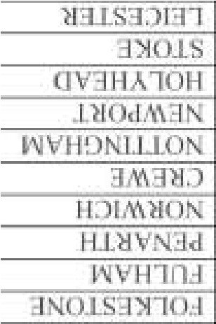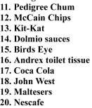
1

Red handed

2

Rolex

3

Quality Street

4

St Andrew's

5

Edward III

6

90

7

Bowler

8

Roses

9

Vinius

10

Earth

Quiz answers

Advertising Feature

Soanes Poultry welcomes Aimee Dawson to the production team

More people news this month with the announcement that we have created another new role in our production team.

Aimee Dawson from Driffield has joined the business as Primary Process Manager to organise the day to day running of the processing department.

She joins us from an abattoir in Leeds where she was Quality and Production Manager.
“It’s a very exciting time to be joining the team at Soanes Poultry. Every day is different, and I thrive on new challenges, so I’m really looking forward to working with the team to make a difference,” said Aimee.

Soanes Poultry’s Head of Operations, Simon Rodgers said: “We’re delighted to welcome Aimee to the team. Her experience will be invaluable as we continue to grow the business and we hope that she’ll be very happy here.”

When she’s not working, Aimee enjoys hiking in Yorkshire with her trusted side kick - border terrier, Bramble, cooking and entertaining for friends. She also likes reading and researching about history and then finding new places to explore.

Aimee’s favourite chicken based meal is homemade Chicken and Lentil Balti served with Motor Paneer.
Advertisements
Advertisement
Advertising Feature

Regular group activities

Weekly Groups
Tuesday YCA | 2.00-2.40pm Zoom
Thursday Middleton Movers  June | 2.00-3.00pm Zoom or Garden
1 Village Hall Committee | 2.30pm TBA
7 Parish Council | 7.00pm Reading Rooms
11 Book Group | 10.30am Kirkburn
24 Yorkshire Countrywomen | 7.00pm Zoom

LOCAL CONTACTS Bell Ringing Chris Atkin |  | 217285
Book Group/Middleton Movers | Lyn Dennis | 219500
Bowls Club | Rob Bradley | 217435
Country Women’s Association | Christine Johnson | 217374
First Responders | Chris Brent | 219469
Line Dancing | Pat Pottage | 217516
Methodist Chapel | Jane Gray | 07870 562455
Middleton Messenger | Mike Kelly | 07713 620912
 | Lyn Dennis | 219500
 | Tina Walker | 217242
Middleton Womblers | Andrew Naylor | 219072
Parish Clerk | Sandra Morrison | 01262 470496
Pilates | Ian Stephenson | 07973 755717
Reading Rooms | Kath Bentley | 217456
Recreation Club | Dave Newlove | 07901 833784
St Andrew’s Church | Rev Jane Anderson | 219471
St Andrew’s Church Warden | Roger Lowe | 217656
Table Tennis | Louise Newlove | 217801
Village Hall | Lyn Dennis | 219500
Village History | Geoff Wisher | 217517

